**Basic Programming**

Array 2

Assignment

Sub-section a, b, and c



MUHAMMAD BAIHAQI AULIA ASY’ARI

2241720145

CLASS 1I (INTERNATIONAL)

INFORMATICS ENGINEERING­­

INFORMATICS TECHNOLOGY

STATE POLYTECHNIC OF MALANG

Contents

Assignment 3

a 3

b 4

c 5

# Assignment

## a

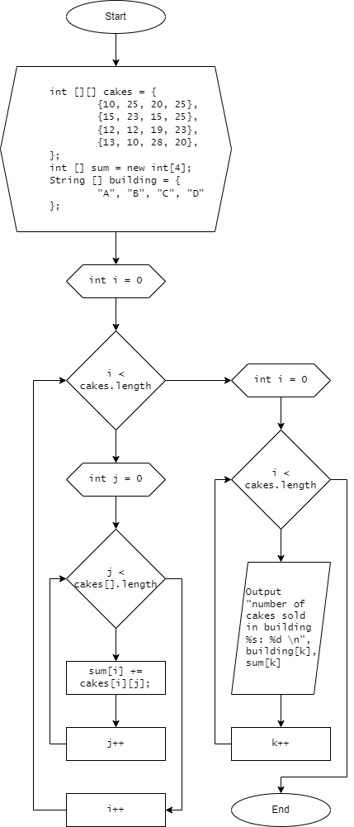

## b

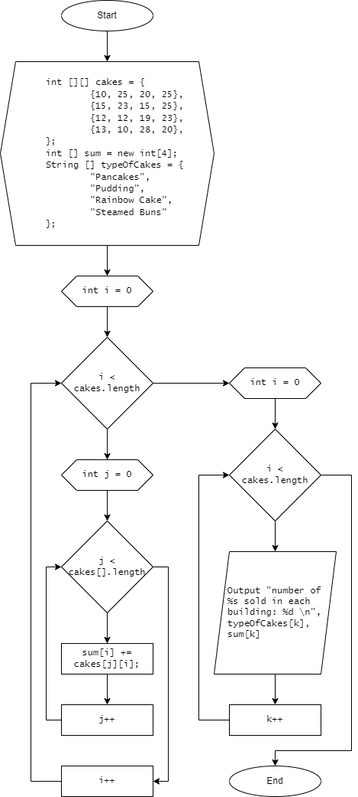

## c

